- Download a small dataset of 10-15 songs with features like danceability, energy, and popularity (you can create a CSV manually or use any open dataset), then calculate the Pearson correlation coefficient between danceability and popularity using pandas.
ANSWERS:
- 0.178487964
corelation
0.178487964

Very Low Corelation

- Given a list of IPL players with their total runs and number of Instagram followers, use scipy.stats.spearmanr to calculate the Spearman correlation between runs and followers, and interpret whether higher runs generally mean more followers
ANSWERS:
- 0.905921
spearmen_corealation
0.905921304

Very Strong Positive Correlation

- Create a correlation matrix for three Flipkart product features: price, user rating, and number of reviews, using pandas' corr() method, and display the result.
ANSWERS:
Result:
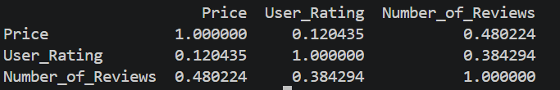

- Visualize the correlation matrix you created in the previous task as a heatmap using seaborn's heatmap() function, and customize it by adding annotations and a color bar.
Hint: Use sns.heatmap(corr_matrix, annot=True, cmap='coolwarm').
ANSWERS:
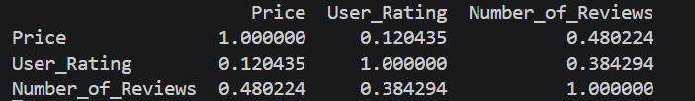
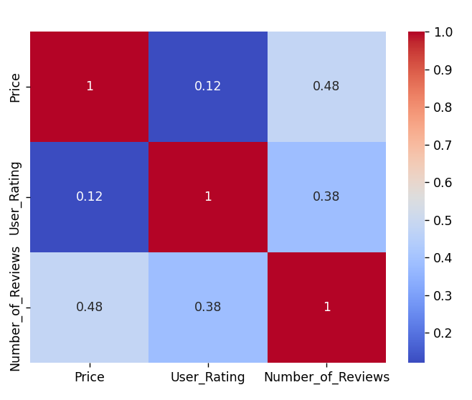
- List two potential pitfalls when interpreting correlation coefficients in data from real apps like Zomato or YouTube, and give a short example for each showing how correlation can be misleading.
ANSWERS:
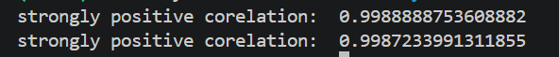
Strongly positive corelation
- High OrderValue cause high Delivery charges. And Low orderValue cause Low Delivery charges

